SOP for Monitoring the Subscribers from OSB Notification Server.
Login to WebLogic console.
http://172.20.10.60:7001/console/
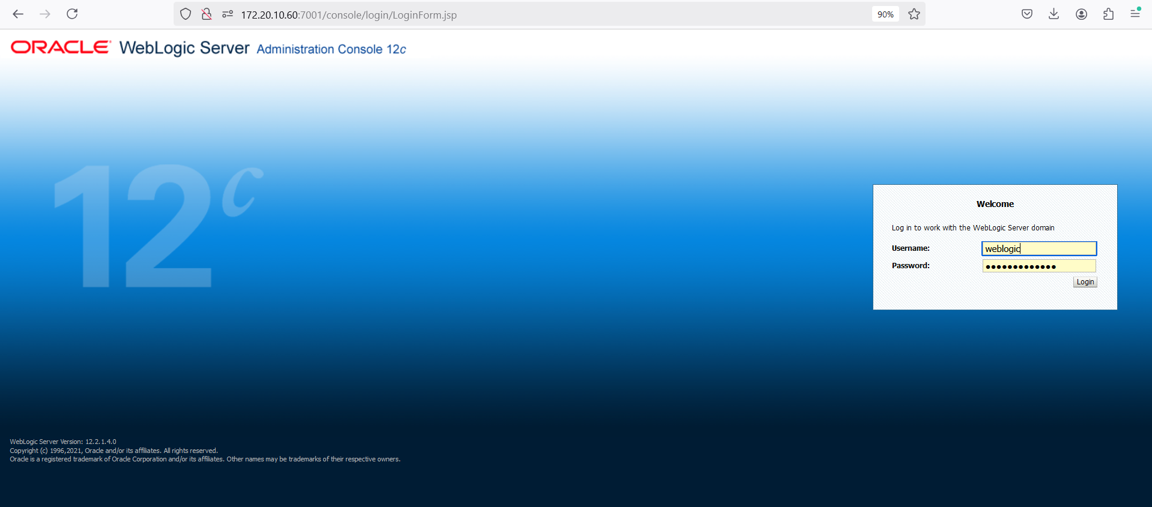

2.click on “JMS Module”
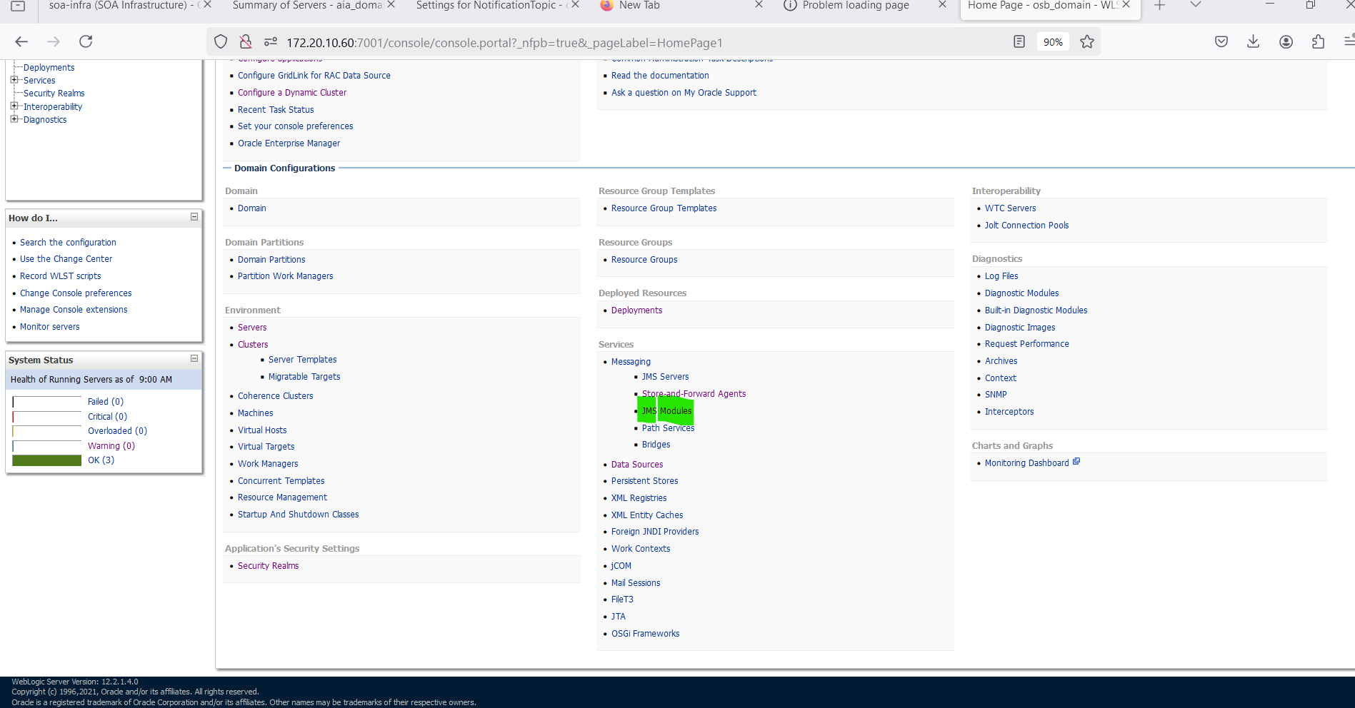
Click on ECE folder
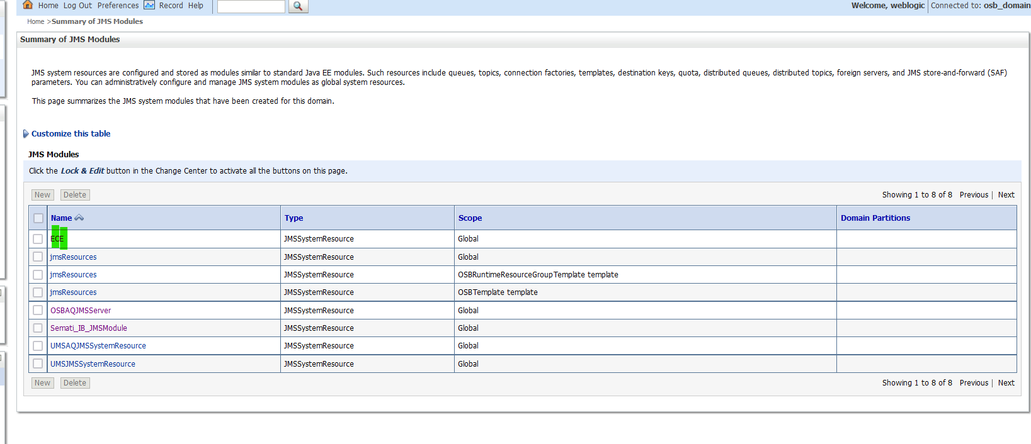

3.Click on NotificationTopic

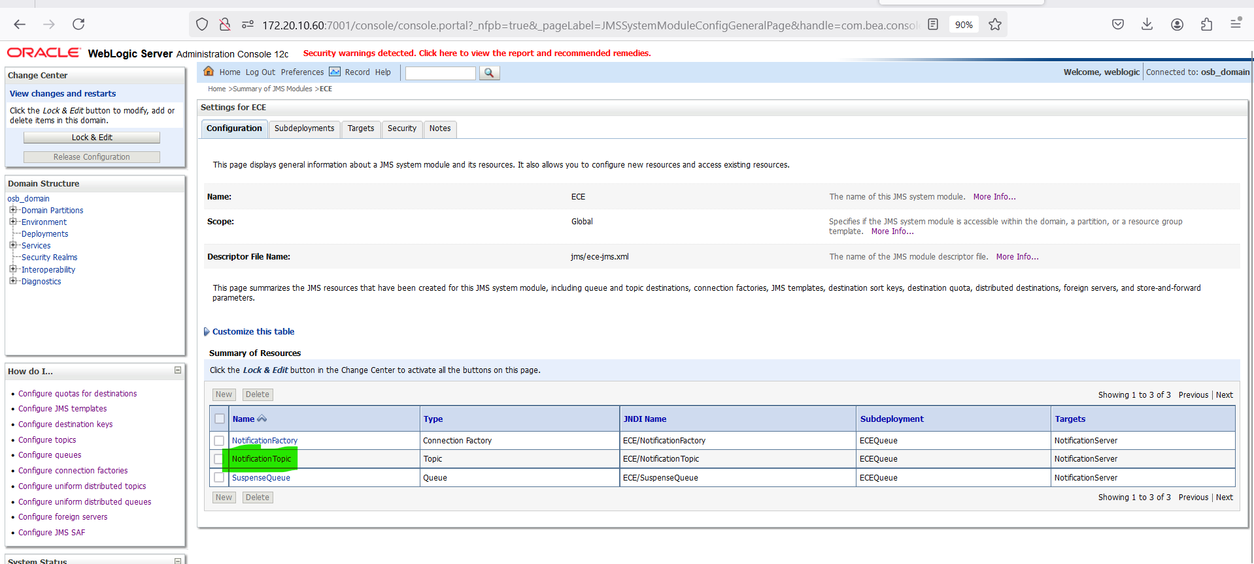
4.Navigate to MonitoringDurable Subscibers
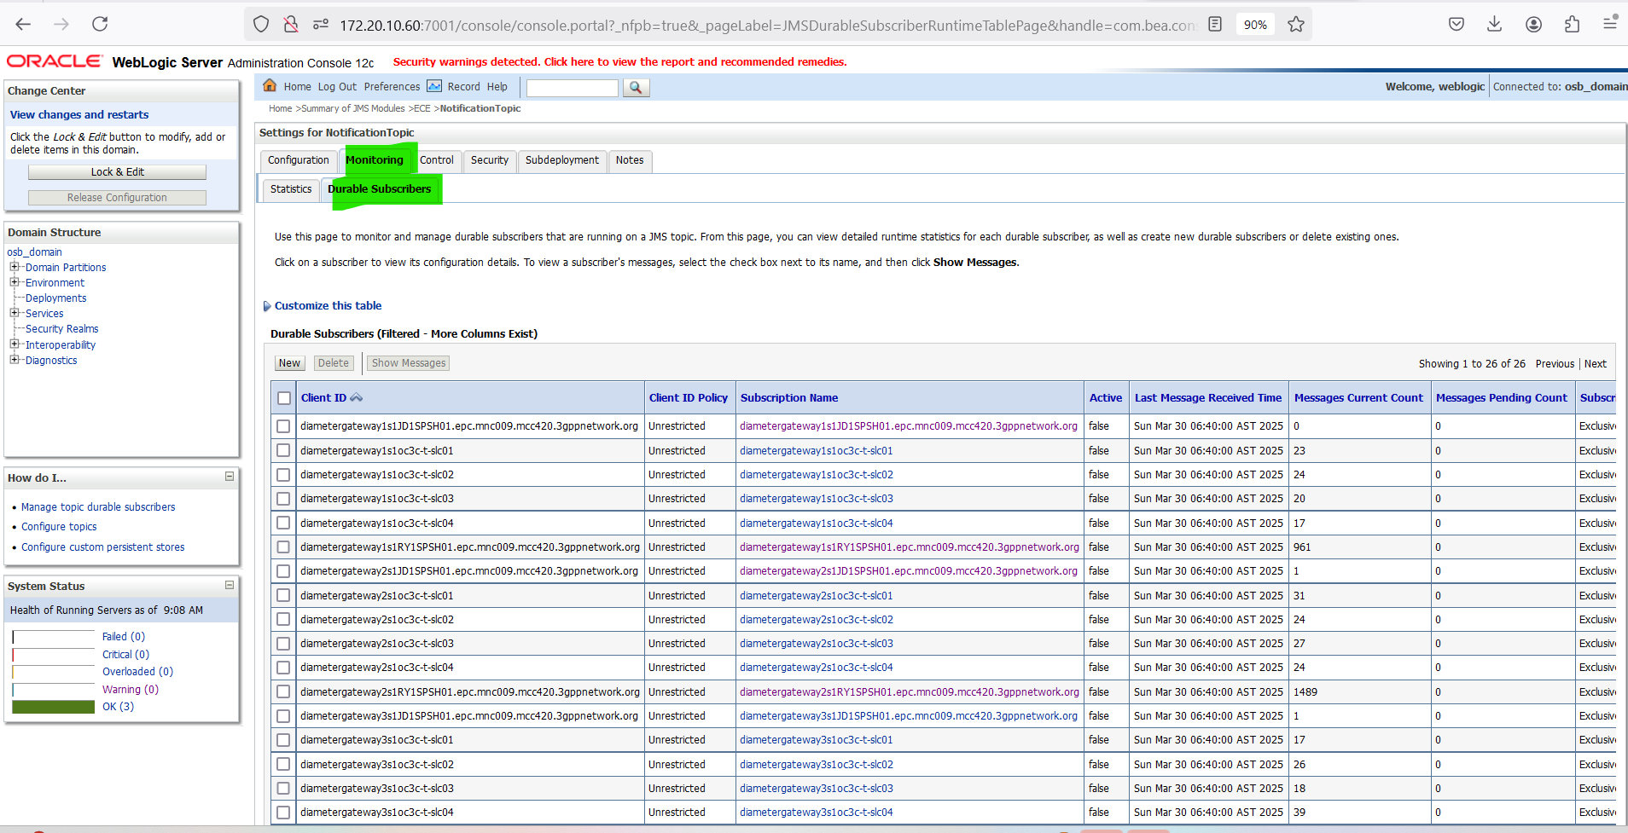
Check if all subscribers are in “True” state.
